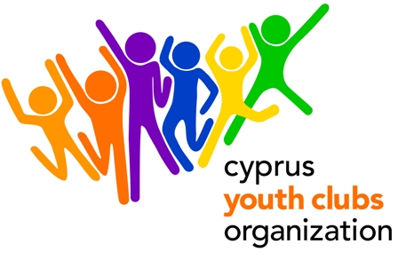
The endless world of music-Creating Bonds

PROJECT OUTLINE
- Project title: The endless world of music-Creating Bonds
- Organization: Cyprus Youth Clubs Organization (CYCO)
- Main theme for the project: Using Music as a tool for communication, alternative ways to produce music, music potentials, music in our lives.
- Number of participants: We encourage organizations to participate with 4 people each and 1 leader (gender balanced group).
- Age range for participants: 18- 25 (20% can be 25-30). No age limit for the Leaders
- Project type: Youth in Action (Action 1 – Youth for Europe/ Sub-Action 1.1 Youth Exchanges)
- Organization’s Country: Cyprus
- Place: Cyprus
- The project starts: 02/01/2012(arrival date)
- The project ends: 08/01/2012 (departure date)
- Deadline for applications : 22/08/2011
- Contact person: Giorgos Kafkalias
- E-mail: giorgos.kafkalias@cyco.org.cy
- Tel.: +35722323260
- Fax: +35722321979
- Summary of the project: “The endless world of music-Creating Bonds” is a youth exchange concerning young people aged 18-25(20% can be 25-30). Young people that have music as a hobby or just use music as a way to express themselves can participate to this Youth Exchange. Our main goal is for young people to get to know the endless world of music. To get familiarized with the potentials of music .To realize the connection between music and our mood- psychology and mental health. To create and produce music from objects that have nothing to do with music instruments as we know them. To improvise with sounds and music that is not even based on the theory of music. Interactive games, exchange of opinions and ideas on different kinds of music of the participating countries. It’s going to be a pleasant experience, which aims to create strong bonds between the participants, which will enhance creativity, the need of expression, communication, humor and at the same time knowledge in the field of music.
- How to participate: Send us a short description of your organization and the link to your website (if available). After you fill in the Part 3 send the scanned version to Giorgos Kafkalias giorgos.kafkalias@cyco.org.cy or fax it to +357 22321979 and mail the original to:

GIORGOS KAFKALIAS
CYPRUS YOUTH CLUBS ORGANIZATION
Platia Iroon 1, Ag. Mamas, Lakatamia, 2330, CUPRUS
CYPRUS

- Financial aspects: Participants will be reimbursed for the 70% of the travel cost on display of their boarding passes. Reimbursement of travel costs will only be done upon full attendance in the activity and presentation of the original tickets with boarding passes and receipt/invoices.
Food and accommodation is paid. Participants will be required to pay a participation fee of €40.
- Safety & Insurance: We will require copies of the travel insurances before travelling to Cyprus.

